Concept and implementation of a smart mirror

**Patrik Toth, Andras Toth, Szabolcs Meszaros, Jozsef Halasz**

Obuda University, Alba Regia Technical Faculty

[patrikthetoth@gmail.com](mailto:patrikthetoth@gmail.com)

[sba.andras.toth@gmail.com](mailto:sba.andras.toth@gmail.com)

[villam983@gmail.com](mailto:villam983@gmail.com)

[halasz.jozsef@amk.uni-obuda.hu](mailto:halasz.jozsef@amk.uni-obuda.hu)

*Abstract*—In recent years, we have seen various smart devices penetrate most aspects of our lives. These devices connect to the internet and sometimes to other devices in order to offer features otherwise not possible. One of the areas in which these devices have yet to earn widespread adoption is the bathroom. Our goal is to create a smart device that can fill this role, a mirror that can identify its users and display relevant information through a display. While the idea of a smart mirror is not new, we believe we can offer new functionality via state-of-the-art facial recognition, and innovative features. In this article, we will discuss the current state of the project, our methodology in the various measurements and the implementation of modern technologies, as well as our aims for the future.

Keywords: Face recognition, Intelligent systems, Smart device, Mirror

# Introduction

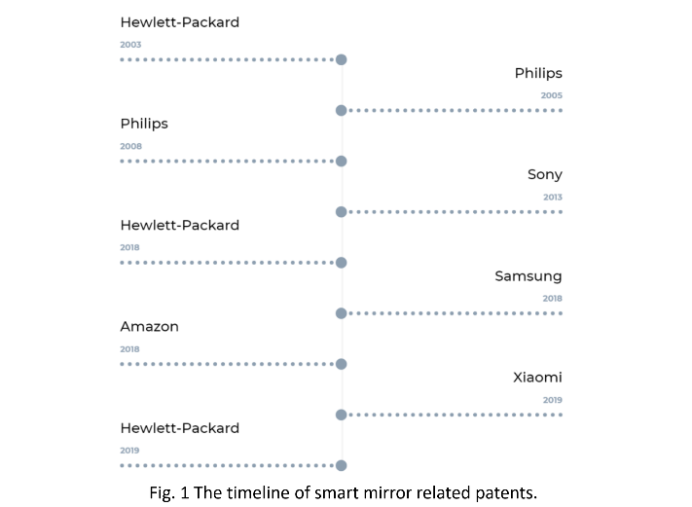Smart devices are becoming a part of our everyday life more and more. Most people use smartphones and other linked devices to optimize their time usage and lifestyle, living in synergy with the connected world. As smart devices are a common occurrence now, smart technologies started to appear in buildings, especially in homes, to be a part of this interconnected phenomenon that is called Internet of Things. This interconnectedness in smart homes was the theme of the article of Vincent Ricquebourg et al [1] .

Fig. 1 The timeline of smart mirror related patents.

One territory in the smart home landscape is still relatively uncharted. Many big brands filed patents related to smart mirrors as shown on timeline in Figure 1, but only small companies and startups have available products.

During the survey of related works many projects used similar hardware and software components:

B. Yuga Vamshi et al. envisioned an appointment alert system combined with a smart mirror [2].

Another, similar smart mirror system was described in the article of Abhishek Pathak et al [3].

Some of the inner workings of the OpenCV framework were described in the article of Piyush Maheshwari et al. [4] and Pranul S. Chheda et al. [5]

The goal of the present paper was to establish a smart mirror system, to assess the level of light transmission and to test the efficacy of face recognition in the present system.

# Methods

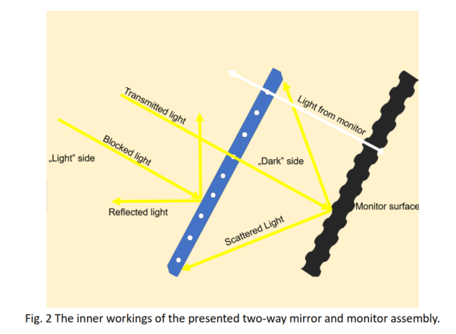**Light Transmission.** In order to achieve an essential “floating image” look in our mirror, the light from the display needs to penetrate the reflective material on the acrylic sheet. The inner workings of the mirror assembly is shown on Figure 2. A two-way mirror with a reflective coating that has many microscopic holes which allows light from both sides to pass through can be purchased from numerous sources, however, no information was provided about the ratio of the surface area of the light-transmitting holes to the light-reflective coating. This is crucial in determining the feasibility of this project.

If the coating blocks too much light from the monitor, the image will be too dim to see, and the opposite is also true.

**Experiment 1:**

Measuring light transmittance of the two-way mirror.

For this measurement, a photoresistor was used, and was attached to the surface of the monitor and the mirror using black electrical tape in order to eliminate environmental light. The electrical resistance of the photoresistor was then on both the monitor and the mirror at various color temperatures. Two different digital multimeters were used to carry out these measurements.

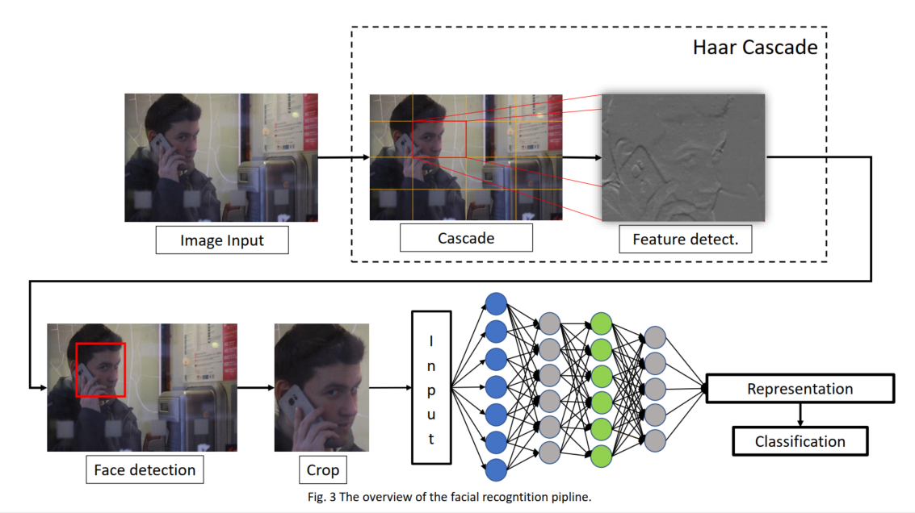

**Face Recognition.** The OpenFace open source project based on FaceNet was used for the face recognition part of the mirror. FaceNet and the OpenFace implementation uses a Deep Learning Convolutional Neural Network (CNN) to produce a 128-dimensional vector representation of a person’s face. The overview of the facial recognition pipeline is shown on Figure 3. This differs from other attempts at face recognition using CNNs because the CNN is used for representation, not classification, thus it offers several advantages. Adding users to the dataset does not requires the network to be re-trained and as the representation is a vector, simple Euclidian subtraction can be used to compare faces, and adjusting the distance threshold can be used for fine-tuning the sensitivity of the classification.

**Additional Technologies.** Theoretically, OpenFace could be used with images captured from the camera directly, however, as it is the case with many Neural Network based applications, large input dimensions will quickly lead to memory and execution time limitations. While OpenFace is the backbone, in order to implement a real-time face recognition pipeline, other technologies, such as OpenCV, an open-source computer vision library initially developed by Intel would need to be utilized. OpenCV not only provides an easier way of accessing video feed from the camera but offers some powerful algorithms such as Haar Cascade.

**Haar Cascade** is an object detection algorithm. It searches for high contrast, or Haar-like features, in an input image. By using a pre-defined feature set designed for detecting human faces, the position of the face in the image can be determined and then cropping the image reduces the computational complexity of the CNN. Haar Cascade is very fast on modern hardware, mostly due to its cascading process. It divides the image into many smaller frames and looks for matching elements to the pre-defined features. This search for features is done in increasing complexity, so the algorithm quickly disregards those frames that do not match with the features it seeks.

In order to establish the efficacy of the face-detection algorithm, three additional experiments were also established.

**Experiment 2:**

The following experiment measured confidence value, the percentage which shows how sure the system is about the user’s identity was used to collect data. For each user 20 pictures were provided as suggested in the paper of Piyush Maheshwari [4].The data collection was performed under constant light intensity, with up to 8 users.

**Experiment 3:**

To establish differences between different faces, confidence values were gathered in 5 different users under constant circumstances. The measurements were repeated ten times in a random order.

**Experiment 4:**

In order to establish the effect of the unknown image number, a systematic data collection was performed to assess the practical limit of recognition in the present setting. At each level, the data collection was repeated ten times, in a random order.

**Statistical analysis.** Statistica 7.0 was used to analyze datasets. A General Linear Model (GLM) was used to assess the effect of the size of the Unknown datasets. Newman-Keuls post hoc comparisons were run to establish differences between groups. The level of significance was set at p=0.05.

# Results

**Experiment 1:**

The gathered values of the two-way mirror’s transmittance were promising. The mirror’s measured average light transmittance was 20.3%.

**Experiment 2:**

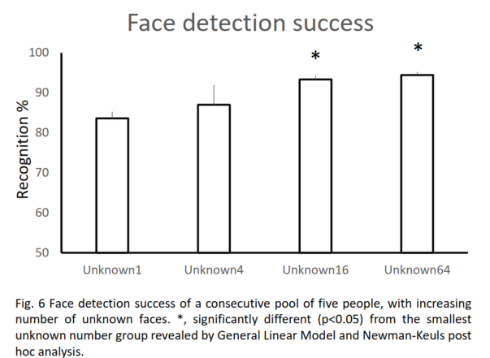As Figure 4 shows that with two registered users an average confidence of 98.4% was measured, and 3 users provided an average confidence level of 95.05%. The number of users was increased to 8. Also presented on Figure 4 the confidence value of the tested user dropped significantly, down to an average of 73.69% and even lower when we introduced the so-called Unknown user. At this point the average confidence value was 67%.

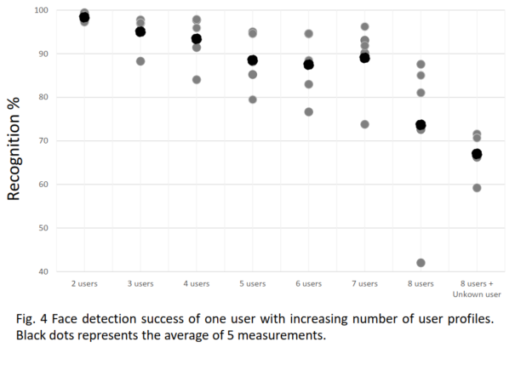

**Experiment 3:**

In this scenario, confidence values of 5 different users were recorded. Data are shown on Figure 5. Huge interindividual-differences can be noticed. User E shows higher divergence which was likely the result of producing images with varied facial expressions during the session.

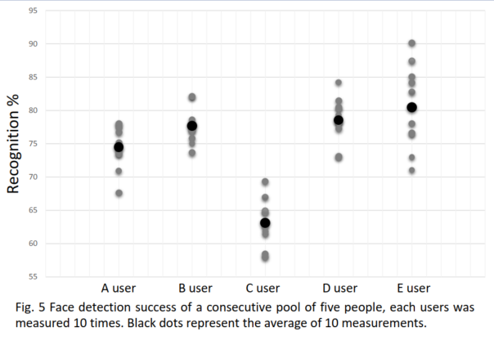

**Experiment 4:**

The next step was to fine tune the size of the Unknown user’s dataset. With every new picture a new human face was introduced into the dataset making it more ambiguous in the process. Hoping that this would increase the confidence values when dealing with more users, as the system can utilize the Unknown user as a reference point to a generic face.

Figure 6 shows that after introducing more and more faces to the Unknown user’s dataset the upper and lower bounds started to raise, which was the desired effect.

# Discussion

The main findings of the present study were the followings. First, with the described hardware and software solutions, a smart mirror system could be outlined. The light transmission was dependent on the measured setup and the color heat and was about 20 %. The face detection was successful and provided useful information sets.

**Experiment 1:**

For the sake of accuracy, two different instruments were used, which turned out to be important as the measuring limit had to be changed on one of the devices after the value of the resistor surpassed 20 kilohms, resulting in reduced accuracy. Unfortunately, no data were described according to the light transmission within the patents and the published smart-mirror systems, but we suppose similar trends in those descriptions.

The following experiments were needed to evaluate the accuracy, performance and scalability of face recognition technologies suggested by other projects. Many of the projects we found during the survey did not discuss these topics. OpenFace and OpenCV was chosen because the surveyed projects seemed to prefer this framework.

**Experiment 2:**

The concept presented in this article was imagined as a piece of technology that can be used by the whole family. On an average there are 2.36 people in a Hungarian household as of 2011 [6] and 2.53 people in an average household in the United States as of 2018 [7]. As shown on Figure 4, these values show that this system is more than adequate for a family of 3. The number of users was further increased to represent a dormitory like use case with a shared living room.

**Experiment 3:**

During the data gathering many facts have been established about how a standardized dataset of a user must be created. In this scenario one picture was created with the user looking directly in the camera and other 8 was created with them looking in the 8 directions of the compass.

It has been established that this type of facial recognition technology is affected by numerous factors. Users who wear glasses need two sets of pictures with and without glasses. Users should keep a straight face during registration as smiling and other facial expressions can influence confidence values.

**Experiment 4:**

Experiment 2 made it clear that the face recognition solution implemented here loses confidence in the recognition beyond 2 users. To counteract the negative effect of more users, an Unknown user was added. Including more faces as an Unknown user shown that it is possible to reduce deviance this way.

**Acknowledgment**

The authors declare no conflict of interest. The authors

would like to express their gratitude to those who have provided their help in the various experiments.

# 

# Conclusions

Smart mirror concept in general and the present smart mirror concept extend our knowledge on smart home concepts in a specific way and enhance our capabilities for using a combination of technologies extending user-friendliness on one side and practical implementation on the other side. Further data collection is required to optimize the solution that can induce a practical breakthrough in the field in terms of everyday usage.

##### References

1. V. Ricquebourg, D. Menga, D. Durand, B. Marhic, L. Delahoche and C. Loge, “The Smart Home Concept: our immediate future”, *1st IEEE Conference on E-learning in Industrial Electronics,* DOI 10.1109, 2006.
2. Y.B. Vamshi, M.A. Sai and M.N. Hussain, “IoT Based Smart Alert System”, *International Journal of Innovative Technology and Exploring Engineering,* vol. 8, pp. 956–959, 2019.
3. A. Pathak, A. Mishra, R. Sarate, S. Bhavsar and N. Patel, “Smart Mirror using Raspberry Pi”, *International Journal of Recent Trends in Engineering & Research,* DOI 10.23883, 2018.
4. P. Maheshwari, M.J. Kaur and S. Anand, “Smart Mirror: A Reflective Interface to Maximize Productivity”, *International Journal of Computer Applications,* vol. 166, pp. 30–35, 2017.
5. P. Chheda, M. Patel, S. Dhage and V. Ghaikvad, “Mirroroid: Enhancing Lifestyle Using IoT”, *2nd International Conference on Advances in Science & Technology,* DOI 10.2139, 2019.
6. KSH Népességtudományi Kutatóintézet, “Demográfiai Portré 2018 – [Demographic Portret 2018]”, KSH, pp. 1–295, 2018.
7. United States Census Bureau, “Families/Time series/Households”, https://www2.census.gov/programs-surveys/demo/tables/families/time-series/households/hh4.xls. [Accessed 08 09 2019].